Triangle
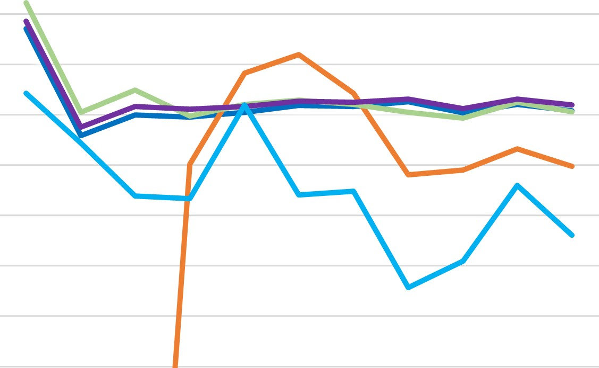
  All Male
  ......—AII GIC
  All Greek
  All Student
  Triangle
3.6
3.4
3.2
3
2.8
2.6
2.4
2.2

S20 F 20 S21 F 21 S22 F22 S23 F 23 S24 F 24 S25

